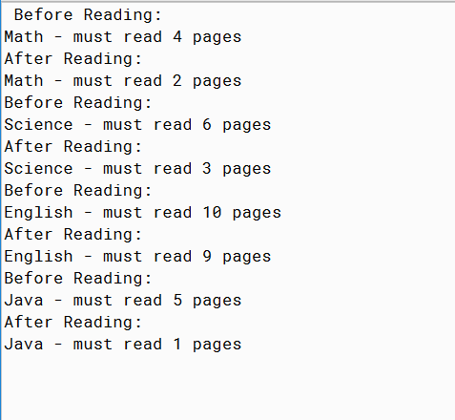

PMR: This program was really similar to the previous assignment. The only change was the processing code. After looking at the examples given it was easy to figure out and it was only one line. I like how these codes are built on top of each other.

HOMEWORK2

/\*

\* By Cole Hudson

\* Date: 3/17/2015

\* Purpose: add an interface to process pages from your homework

\*

\* PMR in README.txt

\*/

public abstract class Homework2 implements Processing

{

//variables

public int pagesRead;

public String typeHomework;

//constructor

Homework2()

{

pagesRead = 0;

typeHomework = "none";

}

//other methods

//create assignment

public abstract void createAssignment(int p);

}

MYENGLISH2

/\*

\* By Anika Jallipalli

\* Date: 3/1/2020

\* Purpose: add an interface to process pages from your homework

\*

\* PMR in README.txt

\*/

public class MyEnglish2 extends Homework2

{

//constructor

MyEnglish2()

{

super();

}

//implemented create assignment method

public void createAssignment(int p)

{

pagesRead = p;

typeHomework = "English";

}

//other methods

//to string

public String toString()

{

return typeHomework + " - must read " + pagesRead + " pages";

}

//implement doReading()

public void doReading()

{

pagesRead -= 1;

}

}

MYJAVA2

/\*

\* By Anika Jallipalli

\* Date: 3/1/2020

\* Purpose: add an interface to process pages from your homework

\*

\* PMR in README.txt

\*/

public class MyJava2 extends Homework2

{

//constructor

MyJava2()

{

super();

}

//implemented create assignment

public void createAssignment(int p)

{

pagesRead = p;

typeHomework = "Java";

}

//other methods

//to string

public String toString()

{

return typeHomework + " - must read " + pagesRead + " pages";

}

//implements doReading()

public void doReading()

{

pagesRead -= 4;

}

}

MYMATH2

/\*

\* By Anika Jallipalli

\* Date: 3/1/2020

\* Purpose: add an interface to process pages from your homework

\*

\* PMR in README.txt

\*/

public class MyMath2 extends Homework2

{

//constructor

MyMath2()

{

super();

}

//implemented create assignment method

public void createAssignment(int p)

{

pagesRead = p;

typeHomework = "Math";

}

//other methods

//to string

public String toString()

{

return typeHomework + " - must read " + pagesRead + " pages";

}

//implement doReading

public void doReading()

{

pagesRead -= 2;

}

}

MYSCIENCE2

/\*

\* By Anika Jallipalli

\* Date: 3/1/2020

\* Purpose: add an interface to process pages from your homework

\*

\* PMR in README.txt

\*/

public class MyScience2 extends Homework2

{

//constructor

MyScience2()

{

super();

}

//implemented create assignment method

public void createAssignment(int p)

{

pagesRead = p;

typeHomework = "Science";

}

//other methods

//to string

public String toString()

{

return typeHomework + " - must read " + pagesRead + " pages";

}

//implements doReading()

public void doReading()

{

pagesRead -= 3;

}

}

PROCESSING

/\*

\* By Anika Jallipalli

\* Date: 3/1/2020

\* Purpose: add an interface to process pages from your homework

\*

\* PMR in README.txt

\*/

public interface Processing

{

//methods

void doReading();

}

TESTHOMEWORK2

import java.util.ArrayList;

import java.util.List;

/\*

\* By Anika Jallipalli

\* Date: 3/1/2020

\* Purpose: add an interface to process pages from your homework

\*

\* PMR in README.txt

\*/

public class TestHomework2

{

public static void main(String[] args)

{

//create the arraylist

List<Homework2> homework = new ArrayList<Homework2>();

//create each homework element

MyMath2 math = new MyMath2();

math.createAssignment(4);

MyScience2 science = new MyScience2();

science.createAssignment(6);

MyEnglish2 english = new MyEnglish2();

english.createAssignment(10);

MyJava2 java = new MyJava2();

java.createAssignment(5);

//add each homework element

homework.add(math);

homework.add(science);

homework.add(english);

homework.add(java);

//print out results

for(Homework2 assignment : homework)

{

System.out.println("Before Reading:");

System.out.println(assignment);

System.out.println("After Reading:");

assignment.doReading();

System.out.println(assignment);

}

}

}